**September 19-29, 2025, SUSTech, Shenzhen, China**

Biomedical Engineering Laboratory I (Fall 2025)

Lab 1 introduction to microscopy

**Group 5**

|  |  |
| --- | --- |
| 姚子墨  12312221 | Author Name  Affiliation  City, State, Country |

|  |  |  |
| --- | --- | --- |
| Author Name  Affiliation  City, State, Country | Author Name  Affiliation  City, State, Country | Author name  Affiliation  City, State, Country |

Abstract

*The optical microscope, a cornerstone of scientific discovery, allows human to observe the object beyond the limit of the naked eyes. Its performance is governed by the wavelength of light and the objective’s numerical aperture (NA). Here, we present four practical investigations to test the core principles and imaging techniques of optical microscope. During these experiments, we verified our microscope’s infinity-corrected design by measuring its true magnification, observed the consequent loss of resolution by altering the objective’s NA using different pinhole apertures, demonstrated the effect of phase contrast microscope against the bright-field mode, and applied fluorescence microscope to visualize the specific components within stained cells (BPAE). This lab successfully integrated theoretical optics with hands-on validation, helping us get a further understanding of modern light microscopy in biomedical research.*

INTRODUCTION

The microscope is one of the greatest inventions of mankind. Before its invention, our understanding of the world was limited to what they could see with the naked eye, or with the aid of simple lenses. And in this lab, we mainly focus on optical microscope, which consists of eyepiece, objectives, brightness adjustment knob, coarse and fine focusing knob, stage, light bulb, phase contrast slider, etc.

Microscope resolution is the smallest distance between two distinguishable points. It is limited by the Abbe diffraction limit (d = 1.22λ / 2NA). This means resolution depends on the light's wavelength (λ) and the objective's Numerical Aperture (NA). The NA (NA = nsinθ) measures an objective's light-gathering ability. Higher NA leads to a sharper image.

Modern optical microscopes use a two-stage magnification process, which utilizes lenses in the scope’s objective and eyepiece. One design is the finite tube length microscope (Fig. 1a), while another more modern design uses infinity-corrected optics (Fig. 1b).

The phase contrast microscope is designed for viewing transparent specimens. It makes invisible phase shifts in light waves visible, which involves separating the direct light from light that is diffracted and making them destructively interfere in order to form a biomedical image.

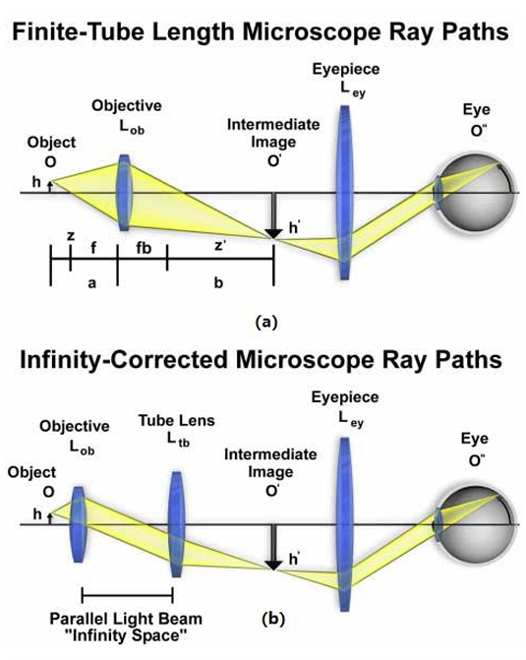

**Figure 1**: Schematic illustrations[1] of (a) finite tube length and (b) infinite tube length microscopy ray paths.

Fluorescence microscopy relies on the Stokes shift. It applies specific light on the sample, which leads to associated excitation of the fluorophore. With the emission filter, the emitted light is project as a fluorescent image to the CCD camera. The combination of images that are processed by different light shows the overall information of fluorescently areas of the sample.

In this laboratory, we performed four complementary experiments to illustrate these principles. First, the actual magnification of an objective lens was compared with theoretical predictions to verify the infinity-corrected design of the microscope. Second, the role of numerical aperture was studied by restricting the objective with pinhole apertures and observing the consequent changes in resolution. Third, phase contrast microscopy was applied to unstained MC3T3 cells to demonstrate its ability to visualize otherwise invisible structures. Finally, fluorescence microscopy was used to image bovine pulmonary artery endothelial (BPAE, Fig. 2) cells, a cell line extracted from tissue excised from the main stem of a young cow’s pulmonary artery, done by P. Del Vecchio in the late 1970s[5]. (Nathan S. et al., Olympus Confocal, 2008) stained with three distinct fluorophores, enabling the simultaneous identification of nuclei, cytoskeleton, and mitochondria. Collectively, these experiments bridged theoretical optics with hands-on microscopy practice and underscored the importance of advanced imaging modalities in biomedical research.

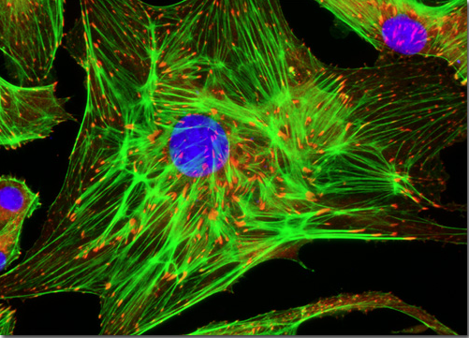

**Figure 2:** BPAE in fluorescence microscopy[2].

MATERIALS AND METHODS

An inverted optical microscope (Olympus CKX53) equipped with 4×, 10×, 20×, and 40× objectives, including phase-contrast capabilities and a broadband mercury lamp, was employed throughout the experiments. A digital imaging system was used for recording data. The following specimens and accessories were utilized: transparent rulers, diffraction gratings (70 and 110 lines/mm, Edmund Optics, transmission diffraction grating), pinhole apertures of three diameters (200 μm, 500 μm, and 1000 μm, Thorlabs P200K, P500K and P1000K), microscope slides, MC3T3 cell samples, and fluorescently labeled slides (Invitrogen FluoCells #1 BPAE Cells, with MitoTrackerTM Red CMXRos, Alexa FluorTM 488 phalloidin and DAPI). Two regular ruler (minimum scale 1mm, total length 15cm and 50cm) were used to measure the image distance and the projection. A 90° bent steel ruler was used to measure the object distance (Fig. 3).

Four experimental modules were carried out. First, under the 4x objective, the true magnification of the optical system was determined by removing the eyepiece, integrating maximum brightness, directly imaging a transparent ruler on the eyepiece tube, measuring the projected scale and comparing it against the scales on the ruler, while the theoretical magnification was calculated by measuring the object distance (o) and image distance (i) of the microscope system and substitute the figures into the formula (1).

$m_{theo}=\frac{i}{o}$ (1)

Two results were compared statistically. Second, the numerical aperture of the 10× objective was modified by sequentially placing pinhole apertures of varying sizes above the lens while observing gratings of different line densities, allowing evaluation of diffraction effects and resolution changes. Third, 20x phase contrast imaging was performed by adjusting the microscope’s phase slider, enabling comparison of MC3T3 cell samples under bright-field and phase-contrast conditions. Finally, 40x fluorescence microscopy was conducted by exciting stained slides with specific illumination channels (UV/blue/green from filtered broadband mercury lamp) and capturing images at different emission wavelengths, followed by staining and merging the channels into an RGB composite. The emission colors were identified through eyepieces, including cyan (nucleus excited by UV), green (cytoskeleton excited by blue) and red (mitochondrion excited by green).

图示

AI 生成的内容可能不正确。

**Figure 3:** Assumed object and image distance in our microscope based on the basic ray path of an inverted microscope[1].

All measurements and image acquisitions were conducted under correct focal distance and repeated by multiple group members to ensure consistency, and scale calibration was applied to microscopic images under different magnification (4x, 10x, 20x, 40x) to convert pixel dimensions into physical units.

Results

Procedure 1 is to measure the True Magnification of an objective. Each group member observed projection of the ruler using the eyepiece tube once. The length on ruler is obtained by directly counting the number of minimum scales(Table 1).

The average measured magnification is 4.2858, standard deviation σ = 0.010897247.

Then we measured two distances: the distance between the objective lens and the sample(o), the distance between the objective and eyepieces(i) (Table 2). The average theoretical magnification is 32.73, standard deviation σ = 0.442379927.

|  |  |  |  |  |
| --- | --- | --- | --- | --- |
| Length on Eyepiece(mm) | 21.50 | 17.12 | 17.11 | 17.11 |
| Length on Ruler(mm) | 5.00 | 4.00 | 4.00 | 4.00 |
| mmeas | 4.3 | 4.28 | 4.2775 | 4.2775 |

**Table 1:** Length on eyepiece and on ruler, and the calculated measured magnification.

|  |  |  |  |
| --- | --- | --- | --- |
| o(cm) | 1.652 | 1.650 | 1.599 |
| i(cm) | 53.46 | 53.80 | 53.12 |
| mTheo | 32.36 | 32.61 | 33.22 |

**Table 2:** Measured object and image distance, and the calculated theoretical magnification.

There is a significant difference between true magnification and the theoretical value. The discrepancy comes from the infinity-corrected design of our microscope. The method we used to measure the object distance is incorrect since the existence of the tube lens (Fig. 1b). The true object distance is impossible for us to acquire given that we are unable to find the accurate position of the tube lens. It proved that our microscope is an infinite-tube length microscope.

Procedure 2 is to alter the numerical aperture of an objective lens. In this procedure we kept the position unchanged, placed pinholes of different sizes on the objective lens and took photos of two different diffraction gratings with digital camera.The smaller the pinhole, the smaller the angle, and the smaller the resolution becomes. (Fig. 4)

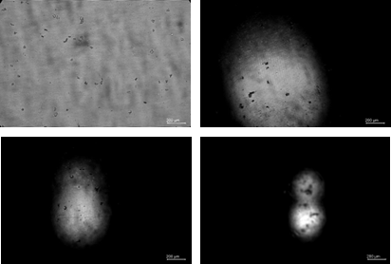

**d**

**c**

**a**

**b**

**Figure 4:** (a)70 lines/mm grating, (b) pinhole aperture 200μm, (c) pinhole aperture 500μm, (d) pinhole aperture 1000μm

It is apparent that the bright spot is getting smaller when the pinhole aperture is shrinked. Moreover, the resolution is also reduced. Stripes are observed in figure 2 to figure 4, but not in figure 5. The view split into two under 200μm pinhole.

Then, we replaced the grating to an 110 lines/mm grating. (Fig. 5.)

**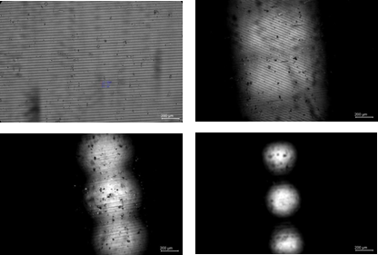**

**d**

**c**

**b**

**a**

**Figure 5:** (a)110 lines/mm grating, (b) pinhole aperture 200μm, (c) pinhole aperture 500μm, (d) pinhole aperture 1000μm.

This time the fringe spacing is reduced. As a result, the stripes are unclear from 500μm pinhole. The diffraction effect became stronger, and we saw three spots in view at most.

Procedure 3 is trying phase microscopy. We used the regular bright field and the phase contrast mode to observe MC3T3 cells in the same place. The 20x objective used in this procedure is examined in advance (Fig. 6.). On the barrel, “LCAch” stands for aberration correction, where LC means long working distance for thick samples like petri dishes, and Ach means achromat objective. “0.40” is the NA. “iPC” stands for integrated phase contrast, which implies that this objective is suitable for this experiment. “∞” means infinity corrected. “1” means the recommended coverslip thickness is 1mm. “FN22” means the field number is 22mm.

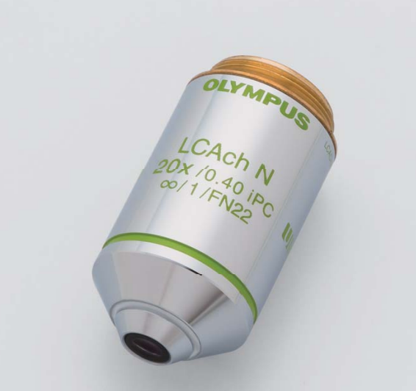

**Figure 6:** 20x objective used in this experiment.

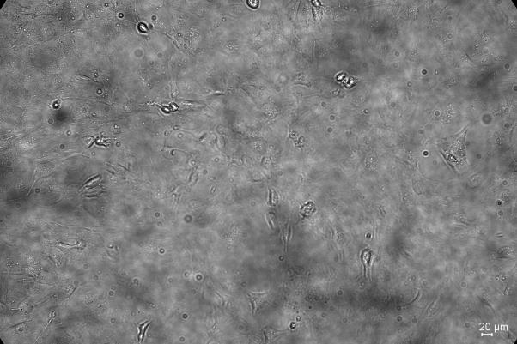

**Figure 7:** Cell image under regular bright field.

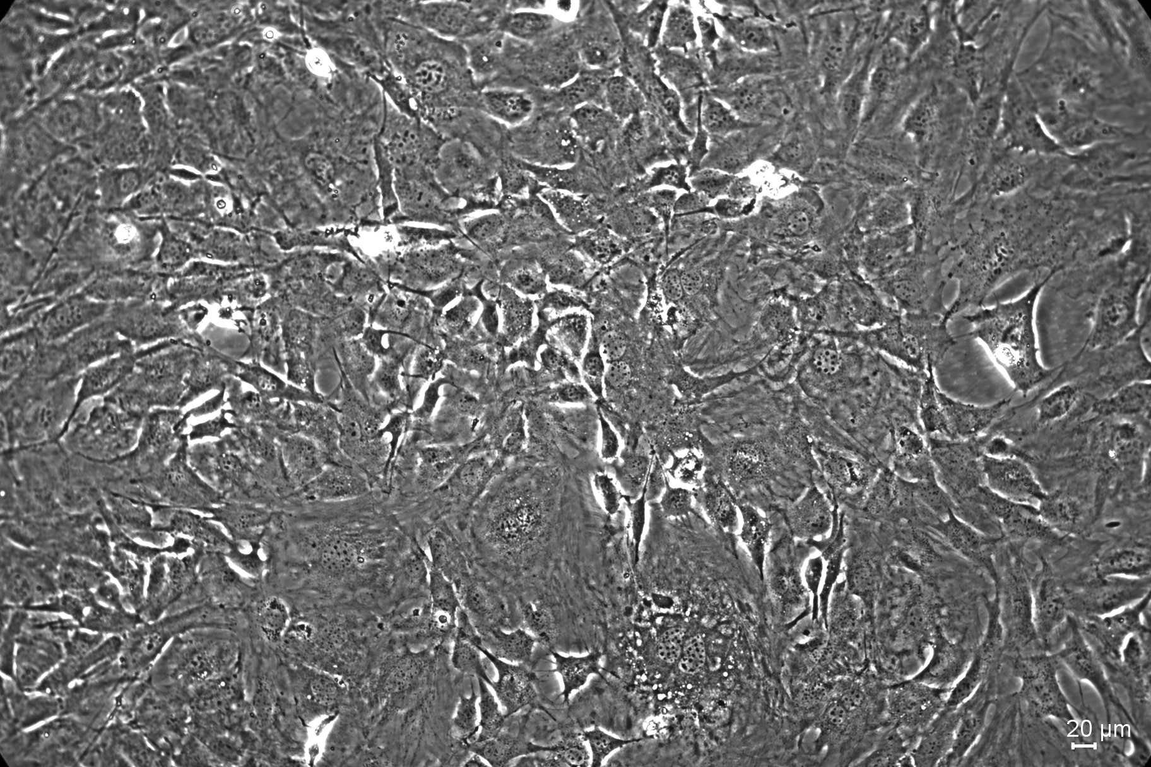

**Figure 8:** Cell image under phase contrast mode.

**.**



**Apoptotic bodies**

**Figure 9:** Part of figure 11, the structure that we assumed to be apoptotic bodies is labelled[6].

The cells were observed under phase contrast mode first and adjusted to suitable focal distance before observed under bright field. The focal distance remained unchanged. Under bright field, no clear cell structure is visible (Fig. 7). Under phase contrast mode, cells with bright edges could be found(Fig. 8). Some possible subcellular structure can be identified (Fig. 9).

Procedure 4 is trying fluorescence microscopy. In this procedure, a mercury lamp is used as broadband light source to excite different fluorescent stains. (MitoTrackerTM Red CMXRos, Alexa FluorTM 488 phalloidin and DAPI)

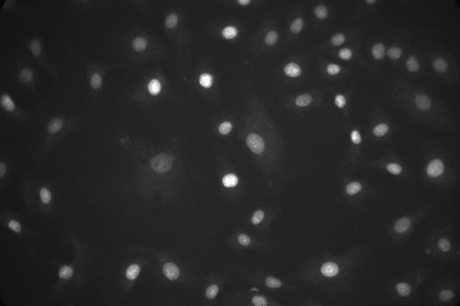nucleus_b255

**a**

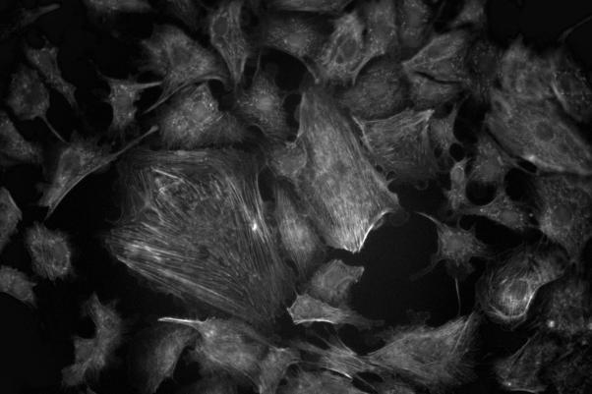cytoskeleton

**b**

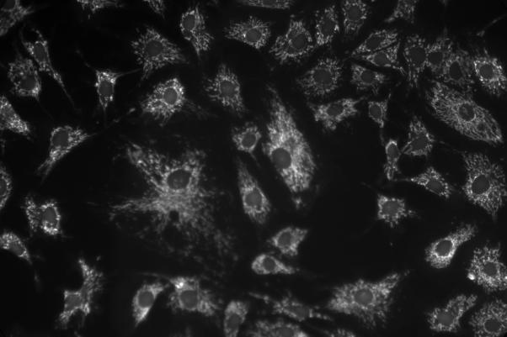mito

**c**

**Figure 10:** Image under mercury lamp, original and tinted image, in (a) UV excitation/blue emission (b) blue excitation/green emission (c) green excitation/red emission channel.

merged_2

**Figure 11:** Merged image of three channels.

DAPI has a excitation peak at 357nm and a emission peak at 461nm, therefore it emits blue light under UV(Fig. 12a). It is located at the nucleus, leading to a demonstration of nucleus position in blue emission channel. We found that nucleus are in the center of the cells. The figure we got from Capture software is in monochrome, and we stained it in pure blue (Fig. 10a).

Alexa FluorTM 488 phalloidin has a excitation peak at 488nm and a emission peak at 520nm (Fig. 12b) Therefore it emits green light under blue light. The stain binds F-actin and show its structure. We were able to see cytoskeleton one by one. The figure we got from the Capture is in monochrome, and we stained it green(Fig. 10b).

MitoTrackerTM Red CMXRos has a excitation peak at 579nm and a emission peak at 599nm(Fig. 12c). It binds mitochondria and emits red light under green light. Mitochondria are in the cell and arrange around the nucleus. The figure we got from the Capture is in monochrome, and we stained it red(Fig. 10c).

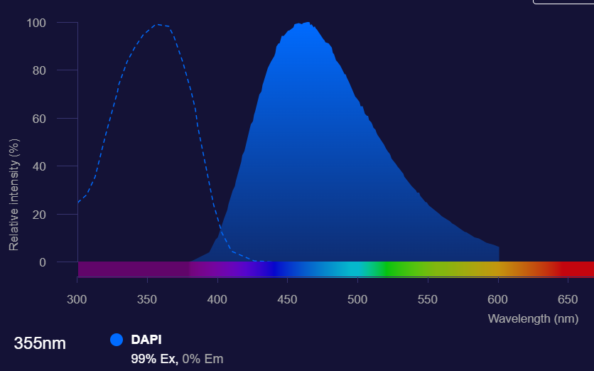图片包含 直方图

AI 生成的内容可能不正确。

**b**

**a**

**c**

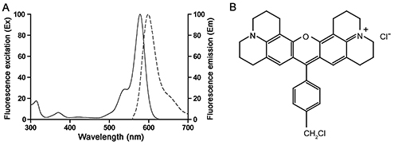

**Figure 12:** Absorption and fluorescent spectrum of (a)DAPI[3], (b) Alexa FluorTM 488 phalloidin[3], (c) MitoTrackerTM Red CMXRos[4].

The three figures are merged in software(Fig. 11). We took the photos in the same position and observed cellular structures. We found nucleus, cytoskeleton and mitochondria in one cell and understood their arrangement.

discussion

This series of experiments systematically demonstrated key principles of optical microscopy and their applications in biological imaging.

The magnification study showed a clear discrepancy between measured and theoretically calculated values. This inconsistency arose because the simple thin-lens model does not apply to infinity-corrected microscopes. In such systems, the tube lens contributes to the final image formation, making the direct measurement of object and image distances unreliable. Thus, the result provided experimental confirmation of the infinity-corrected design of the Olympus CKX53 microscope.

In the numerical aperture experiment, placing pinholes of different diameters above the 10× objective directly limited the cone of diffracted light entering the lens. A smaller aperture reduced the effective NA, causing lower light collection efficiency and degraded resolution. Consequently, fine details such as the 110 lines/mm grating became unresolvable with smaller apertures, as shown in Fig. 5. Additionally, the observation that the image occasionally split into two or more circular fields under the smallest pinhole can be explained by diffraction and imperfect alignment: the aperture introduced multiple diffraction orders, and slight misalignment of the pinhole relative to the optical axis caused only partial portions of the diffraction cone to pass, producing separated sub-images in the eyepiece. These phenomena highlighted the importance of NA in determining both resolution and image fidelity.

The phase contrast experiment confirmed the utility of this technique for visualizing nearly transparent biological cells. Structures that were indiscernible in bright-field became clearly outlined under phase contrast, since phase shifts caused by intracellular components were converted into detectable intensity differences. This demonstrated why phase contrast remains a critical modality in live-cell imaging where staining is undesirable.

Fluorescence microscopy further extended the ability to identify specific subcellular components. By exciting three distinct fluorophores, we were able to simultaneously visualize nuclei, cytoskeleton, and mitochondria. The merged RGB overlay revealed their spatial relationships, illustrating the power of multiplex fluorescence labeling. At the same time, the procedure also underscored practical challenges, such as photobleaching, alignment of optical channels, and the need for accurate scale bar calibration to quantify cellular structures.

Across all experiments, the underlying principle is that image formation depends on capturing and reconstructing diffracted light. Whether through limiting NA, enhancing phase differences, or selectively detecting fluorescent emission, the microscope’s role is to manipulate light paths to maximize useful information. These hands-on procedures reinforced the theoretical concepts and highlighted why modern microscopy integrates multiple complementary imaging modes.

Acknowledgments

I would like to express my sincere gratitude to the members of the research team who contributed to the successful completion of this study. Their dedication, expertise, and commitment were instrumental in the realization of our research objectives. I am thankful for their valuable insights, collaborative spirit, and unwavering support throughout the project.

References

[1] Lab Manual

[2] Florida State University. (2022). Bovine pulmonary artery endothelial cells [Image]. Molecular Expressions Microscopy Primer. Retrieved October 27, 2023, from <https://micro.magnet.fsu.edu/primer/techniques/fluorescence/gallery/cells/bpae/bpaecells.html>

[3]https://www.thermofisher.cn/cn/zh/home/life-science/cell-analysis/fluorophores/alexa-fluor-488.html

[4]https://www.beyotime.com/product/C1049-50%C2%B5g.htm

[5]http://www.olympusconfocal.com/gallery/cells/bpae/bpaecells.html#:~:text=BPAE%20cells%20exhibit%20typical%20endothelial%20morphology%20and%20are,a%20substance%20that%20normally%20narrows%20the%20blood%20vessels.

[6] <https://en.wikipedia.org/wiki/Apoptosis>

[7] chatgpt.com